Abscond Runners

Team Lost

01/18/2022

Version 1.0

**Table of Contents**

**Executive Summary**

**High Concept**

**Features and Synopsis**

**Play Motivation**

Genre, Platform, and ESRB

Audience and Targeted Customers

Threats and Competition

**Game Differentiators/Unique Selling Points**

**Overall Game Design**

**Game Aesthetic**

**Gameplay Board: Game Core Mechanics**

# Executive Summary

## High Concept

- Players race to reach the end of the maze

- Solve puzzles to reach checkpoints(base)

- Survivor essentials to get through to the end

## Features and Synopsis

- The players start by waking up in front of a maze that seems endless

- Each checkpoint is aesthetically different and has different survival kits

- The environment and the conditions change from each checkpoint

- The players will have enemies to fight

- Every player will have equal amount of health to start, and if you die, the game ends for that player

- Players get a title (badge) for every win

- Stat record for every player

## Play Motivation

- Each checkpoint will have better gear, weapons, and essentials

- Players need food and water to survive

- Destroying the structures should provide the player with excitement, joy, and satisfaction.

- Challenge yourself for high scores or your friends for bragging rights.

- Players can rank up

### Genre, Platform, and ESRB

Genre: Survival, Action-Adventure

Platform: PC, Console

Expected ESRB: T for teen ages thirteen and up

### Audience and Targeted Customers

This is a free-for-all game that is aimed for players thirteen and up. It’s a bit graphic making it not so kid friendly since there’s violence in the game. People that are into competition, adventures, and like to show off their survival skills

### Threats and Competition

* Other players
* Maze itself
* Aliens(deceivers)

## Game Differentiators/Unique Selling Points

* It’s a complex maze that has a shifting environment!
* More than one player can win
* 3D platformer game
* All though it’s a free-for-all game, you can work with others to win

# Overall Game Design

## Game Aesthetic

## Gameplay Board: Game Core Mechanics

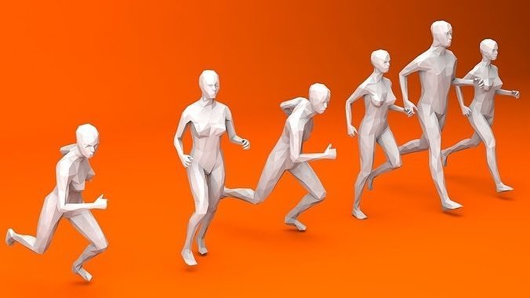Fig.1 - RunningFig.2 - Jumping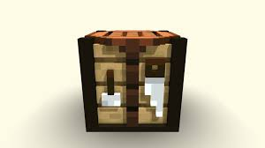Fig.3 - Crafting 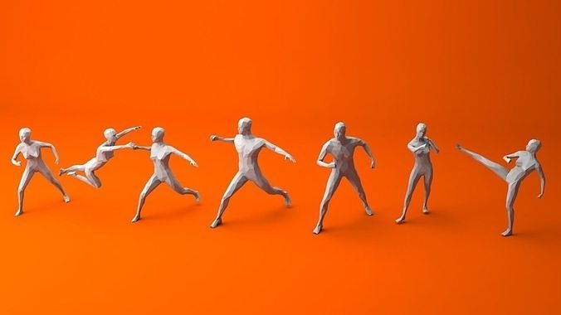Fig.4 - Fighting